Superstore Sales Dashboard
Data Analytics Portfolio Project
Name : Sai Sri Kadari
Tools Used : Python | Pandas | Power BI
Date : March 2026
Dataset : Superstore Sales Dataset (Kaggle)
GitHub : github.com/saisrijagadish36-cmd/ Superstore-Sales-Dashboard
Email : saisrijagadish36@gmail.com
LinkedIn : linkedin.com/in/sai-sri-kadari-229a2b230

PROJECT OVERVIEW
- What is this Project?
This project is a complete Data Analytics case study on the Superstore Sales dataset from Kaggle. The goal is to clean, analyze and visualize sales data to find key business insights.
Dataset Information
- Dataset Name : Superstore Sales Dataset
- Source : Kaggle
- Total Rows : 9,994 orders
- Total Columns : 21 columns
- Time Period : 2014 to 2017
- Location : United States

Tools Used
- Python (Google Colab) - Data Cleaning & Analysis
- Pandas Library - Data Manipulation
- Power BI Desktop - Dashboard & Visualization

Project Goal
- Clean and prepare raw data using Python
- Analyze sales, profit and customer trends
- Build an interactive dashboard in Power BI
- Find key business insights for decision making

STEP 1: LOADING THE DATA
- What I Did:
Uploaded the Superstore Excel file to Google Colab and loaded it using the Pandas library.

Code Used:
from google.colab import files
uploaded = files.upload()

import pandas as pd
df = pd.read_excel("Copy of Sample - Superstore.xls")
df.head()
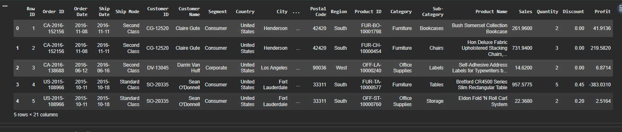
- What I Found:
- File loaded successfully
- Data contains 9,994 rows and 21 columns
- Columns include: Sales, Profit, Category, Region, State, Order Date and more
- First 5 rows displayed correctly

STEP 2: CHECKING DATA QUALITY
- What I Did:
Checked the size, column names and data quality of the dataset using 3 commands.

Code Used:
df.shape # Check rows and columns
df.columns # Check column names
df.info() # Check data types and missing values
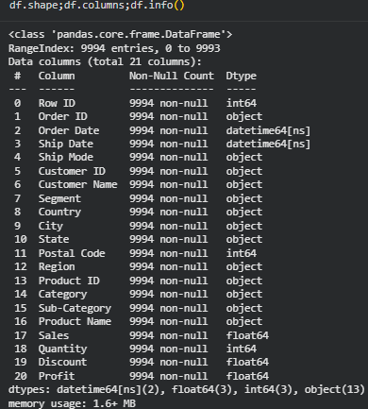
- What I Found:
- Total Rows : 9,994
- Total Columns : 21
- Missing Values: ZERO ✅
Data Types:
- int64 : Row ID, Quantity, Postal Code
- float64 : Sales, Profit, Discount
- object : Category, Region, State, Name
- datetime64 : Order Date, Ship Date

- Why This Step is Important:
Checking data quality ensures our analysis is based on clean and reliable data. Zero missing values means no data cleaning was needed — the dataset is perfect!
STEP 3: ADDING NEW COLUMNS
- What I Did:
Added 3 new columns to make our analysis more powerful and meaningful.

Code Used:
df['Year'] = df['Order Date'].dt.year
df['Month'] = df['Order Date'].dt.month
df['Profit Margin'] = (df['Profit'] / df['Sales']) * 100
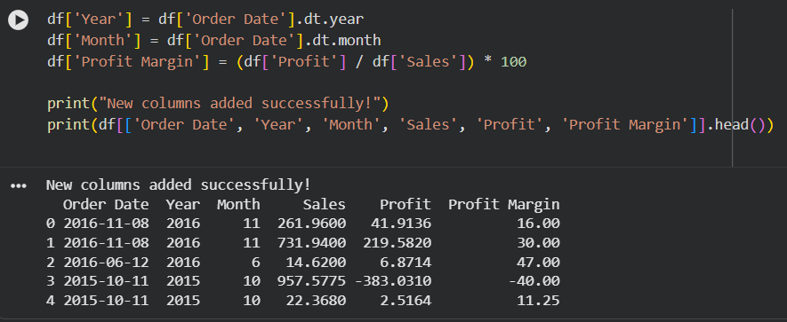
- Why I Added Each Column:
- Year Column
Why? : To analyze how sales changed year by year from 2014 to 2017.
This helps us see growth trends.
- Month Column
Why? : To find which months have the highest and lowest sales.
This helps in seasonal planning.
- Profit Margin Column
Why? : To understand what percentage of sales actually became profit.
Formula: (Profit ÷ Sales) × 100
Example: Sales $100, Profit $12
Margin = 12%
Result:
New columns added successfully!
Total columns increased from 21 to 24.
STEP 4: KEY PERFORMANCE INDICATORS
- What I Did:
Calculated the most important business numbers called KPIs (Key Performance Indicators)

Code Used:
print("Total Sales:", round(df['Sales'].sum(), 2))
print("Total Profit:", round(df['Profit'].sum(), 2))
print("Total Orders:", df.shape[0])
print("Avg Profit Margin:", round(df['Profit Margin'].mean(), 2), "%")
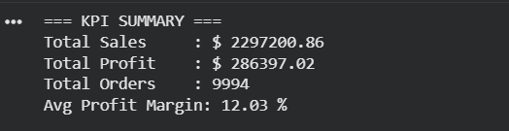
- What This Means:
- The store made $2.3 million in total sales
- Only 12% of sales became actual profit
- Nearly 10,000 orders were placed
- Profit margin needs improvement

STEP 5: SALES & PROFIT BY CATEGORY
Code Used:
category = df.groupby('Category')[['Sales','Profit']] .sum().round(2)
print(category)
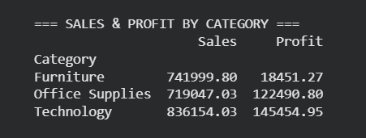

Key Insights:
  - Technology is the BEST category Highest sales AND highest profit!
  - Furniture has a BIG PROBLEM High sale of $742K but only $18K profit — very low margin!
  - Office Supplies performs well good balance of sales and profit

STEP 6: REGION & STATE ANALYSIS

Code Used:
region = df.groupby('Region')[['Sales','Profit']].sum().round(2)
print(region)
states = df.groupby('State')['Sales'].sum().sort_values(ascending=False).head(10)
print(states)
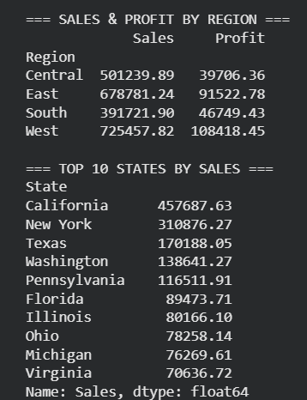
Top 3 States:
- California → $457,687 (Best!)
- New York → $310,876
- Texas → $170,188 (Watch out! Losing money)

Key Insights:
- West region is the strongest
- California alone = 20% of total sales
- Texas has high sales but negative profit
- Central region needs improvement

STEP 7: PROFIT BY SUB-CATEGORY
Code Used:
subcat = df.groupby('Sub-Category')['Profit'].sum().sort_values(ascending=False).round(2)
print(subcat)
print(df.groupby('Category')['Discount'].mean().round(3))
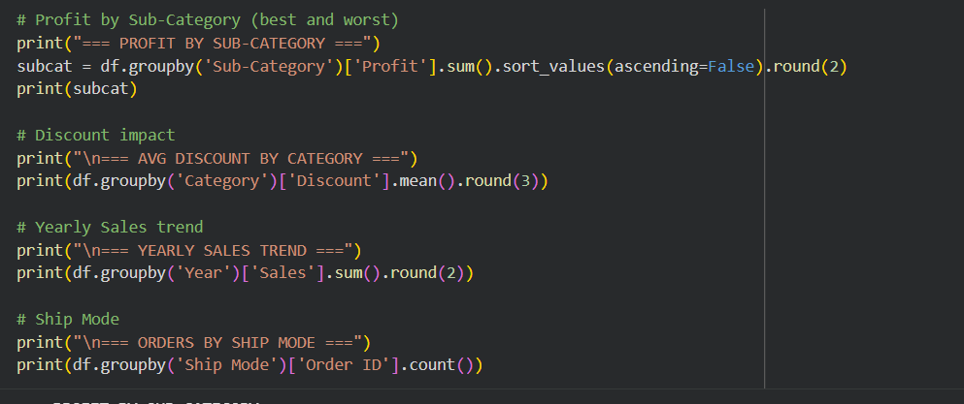
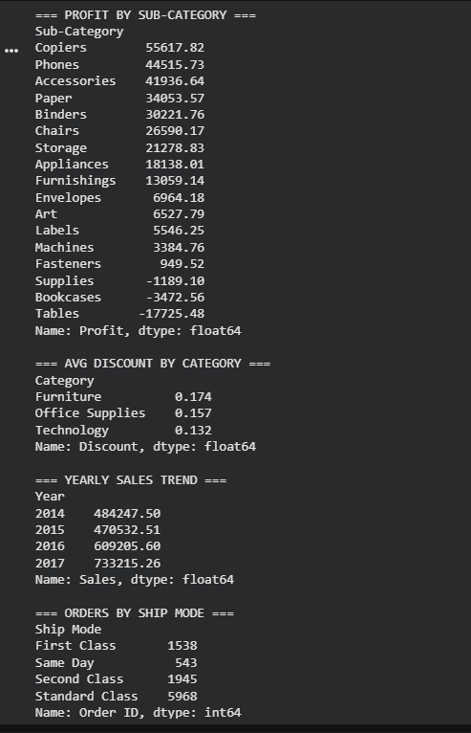
Top 5 Best Sub-Categories:
- Copiers → +$55,617
- Phones → +$44,515
- Accessories → +$41,936
- Paper → +$34,053
- Binders → +$30,221
Loss Making Sub-Categories:
- Tables → -$17,725 ❌ BIGGEST LOSS
- Bookcases → -$3,472
- Supplies → -$1,189
Discount Analysis:
- Furniture → 17.4% avg discount
- Office Supplies → 15.7% avg discount
- Technology → 13.2% avg discount
Key Finding:
- Higher discount = Lower profit!
- Tables and Bookcases get heavy discounts
- which is causing them to lose money.

STEP 8: POWER BI DASHBOARD
- What I Did:
Exported clean Python data to Power BI and built an interactive dashboard.
- Steps Followed:
1. Exported clean CSV from Google Colab
2. Loaded CSV into Power BI Desktop
3. Applied dark professional theme
4. Built 7 visualizations
5. Added Year slicer for filtering

- Visuals Created:
│ 1 │ KPI Cards (Sales/Profit/Qty)
│ 2 │ Sales by Category (Bar)
│ 3 │ Profit by Sub-Category (Bar)
│ 4 │ Sales by Year (Line Chart)
│ 5 │ Sales by Region (Donut)
│ 6 │ Sales by Segment (Pie)
│ 7 │ Sales by Ship Mode (Bar)

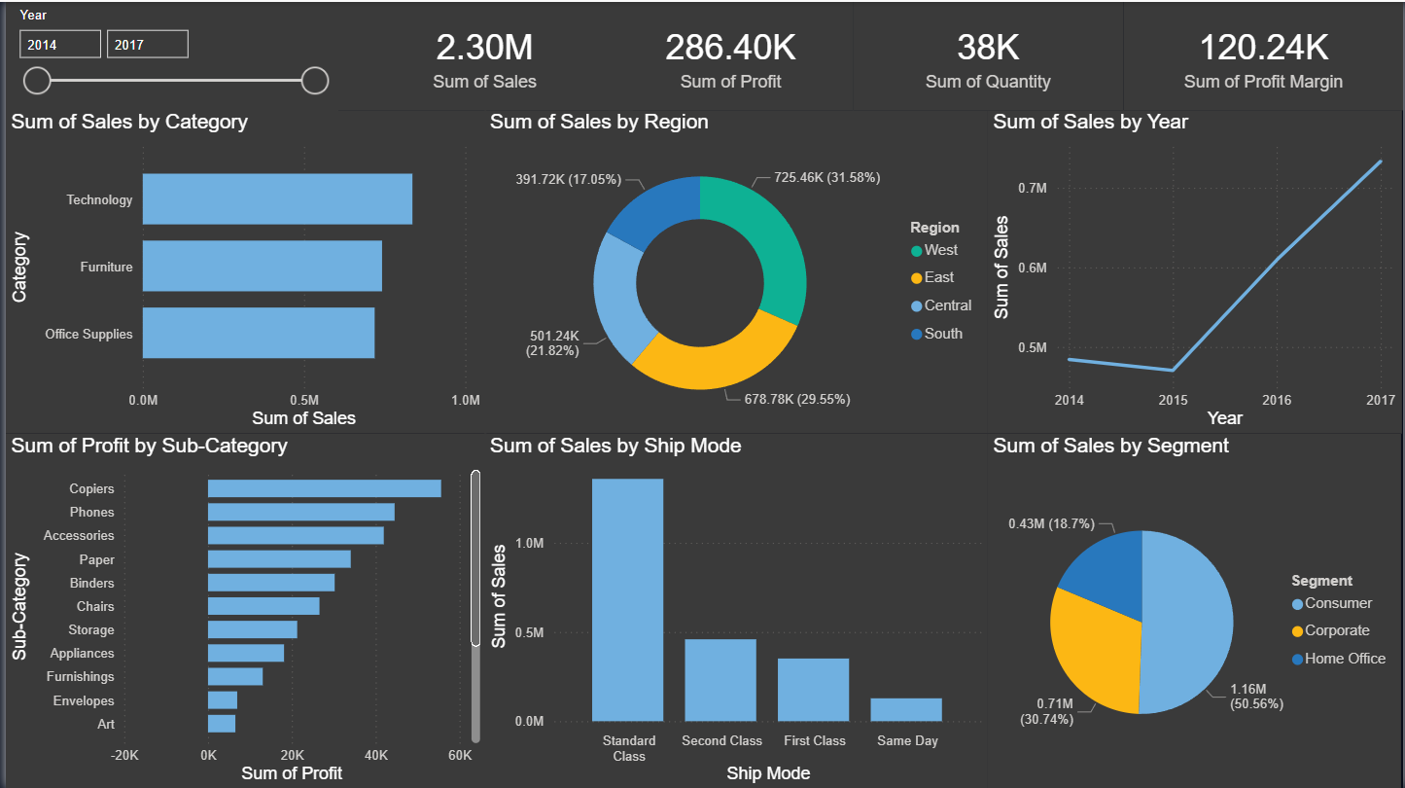

KEY INSIGHTS & RECOMMENDATIONS
Key Insights Found:
Insight 1: Technology Leads
Technology is the best category with $836K sales and $145K profit (17.4% margin)
Insight 2: West Region Dominates
West region leads with $725K sales and $108K profit across all regions
Insight 3: Tables Are Losing Money
Tables sub-category lost $17,725 due to heavy discounting of 30%+
Insight 4: Discount Hurts Profit
Higher discounts directly cause lower profits across all categories
Insight 5: Strong Sales Growth
Sales grew from $484K in 2014 to $733K in 2017 — a 51% increase!
Insight 6: California Dominates
California alone contributes 20% of total company revenue ($457K)
Business Recommendations:
1. Stop heavy discounting on Tables and Bookcases to reduce losses
2. Invest more in Technology products as they give highest profit margins
3. Expand West region sales strategy to other regions
4. Focus marketing on California and New York — top performing states
5. Investigate why Texas has high sales but negative profit

CONCLUSION
- What I Learned:
Through this project I learned how to:
- Load and explore real world datasets
- Clean and transform data using Python
- Create meaningful new columns
- Analyze business KPIs
- Build interactive dashboards
- Find actionable business insights
Tools & Skills Used:
- Python --- Data loading & cleaning
- Pandas --- Data manipulation
- Google Colab --- Cloud based Python notebook
- Power BI --- Data visualization
- GitHub --- Project portfolio hosting

Project Files:
- superstore_clean.csv — Clean dataset
- superstore_Dashboard.pbix — Power BI file
- superstore_dashboard.png — Dashboard image

Connect With Me:
- LinkedIn : linkedin.com/in/sai-sri-kadari-229a2b230
- GitHub : github.com/saisrijagadish36-cmd
- Email : saisrijagadish36@gmail.com

Thank you for reviewing my portfolio!

